**EE316 assignment3 Report**

12112441 曹子惠

* Objective:

Branch-line coupler

1. Insertion loss < 3.8dB
2. Input and output return loss > 22dB
3. Isolation > 25dB
4. Output phase difference = 90°±5°

* Analyze branch-line coupler’s ideal S-parameter

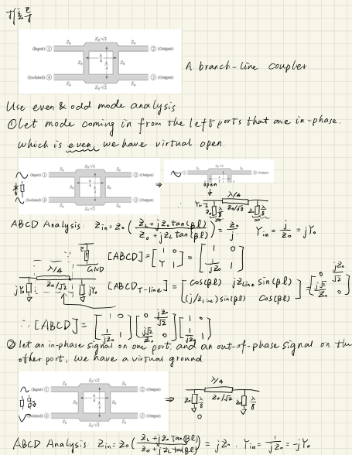

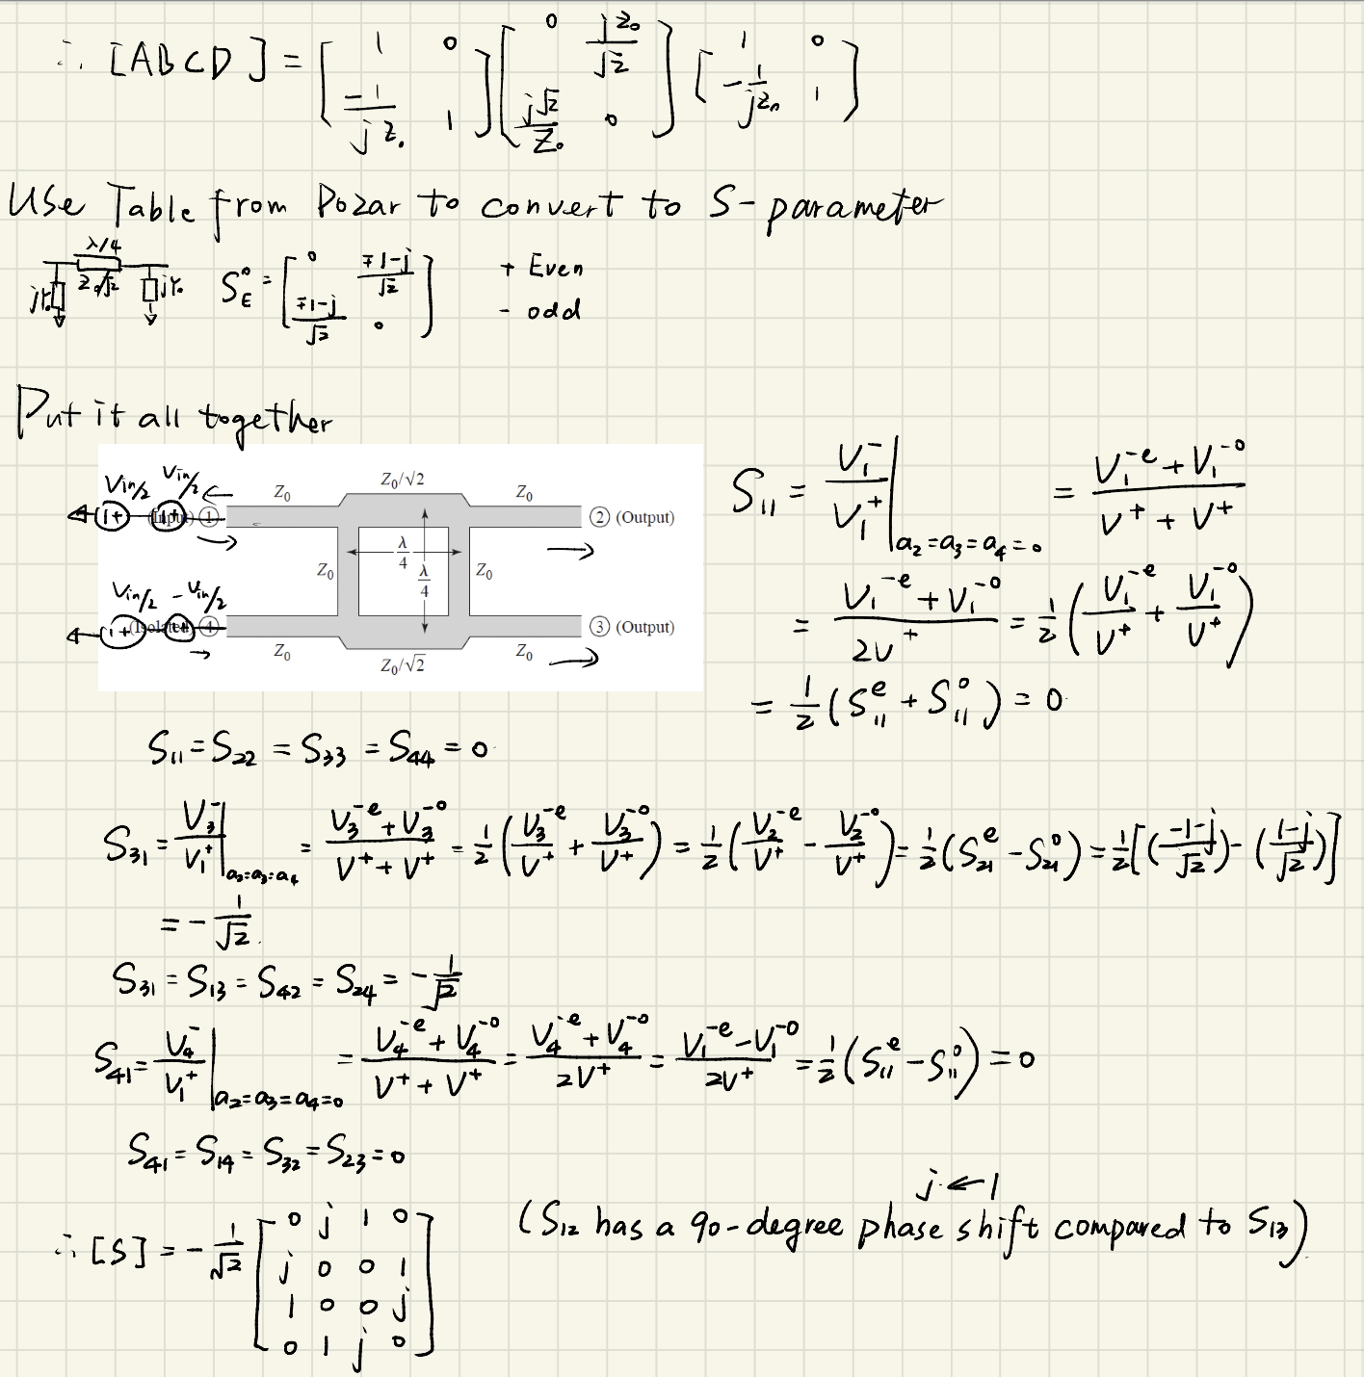

* Describe how to obtain the device dimension

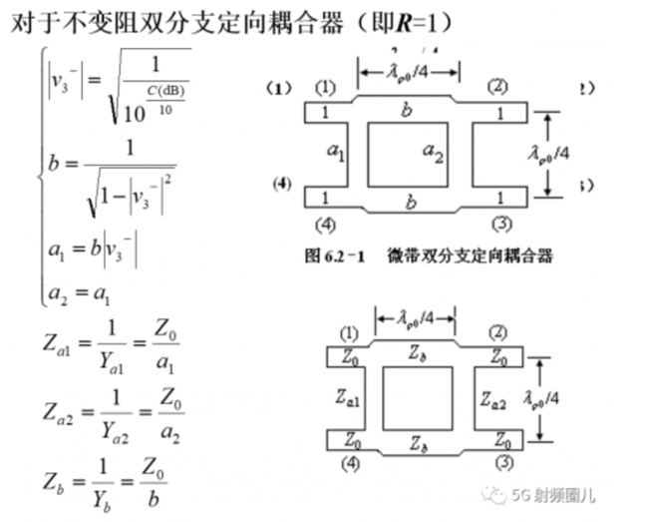

Use the formulas over, as we know $Z_{0}$ =50Ω, F=1.9GHz, $ε$ r=4.3, h=0.8mm,we have:

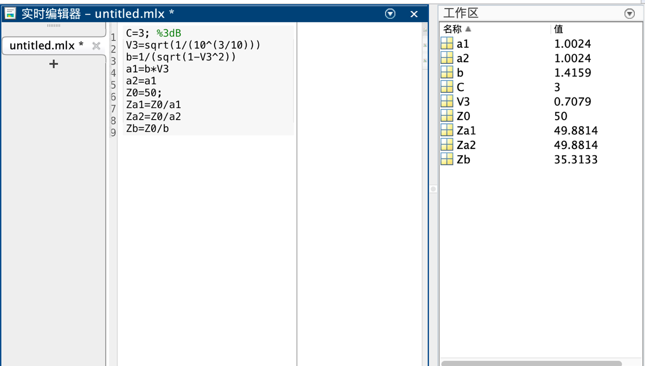

Za1= 50Ohm，Za2= 50Ohm，Zb=35.4Ohm

According to the impedance equation of the microstrip line, we get:

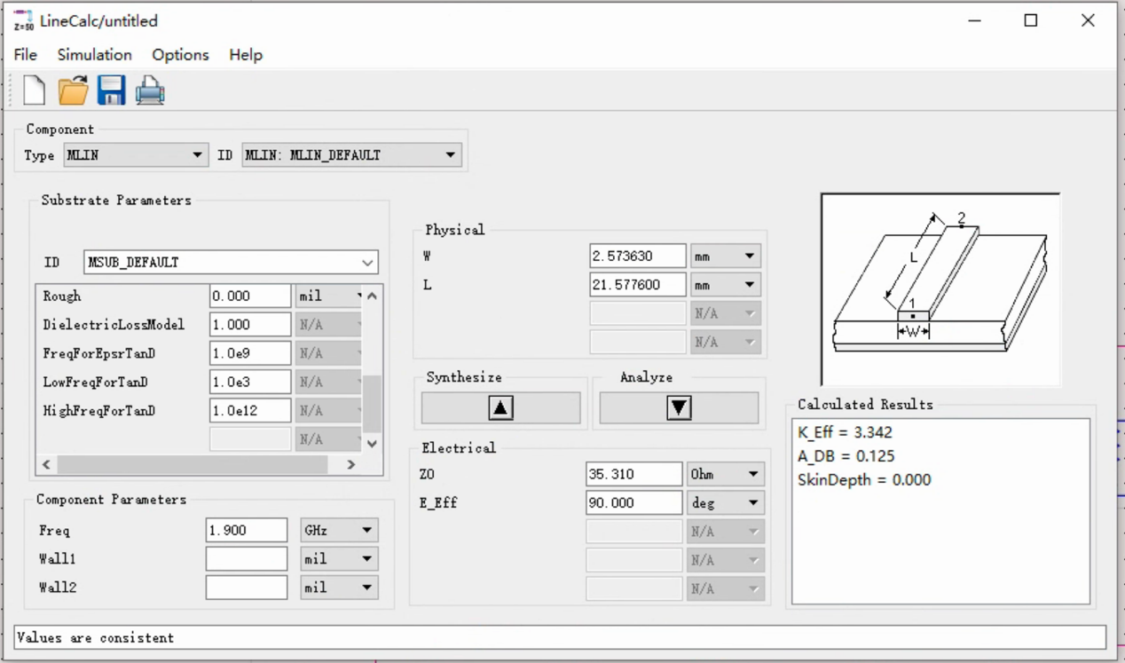

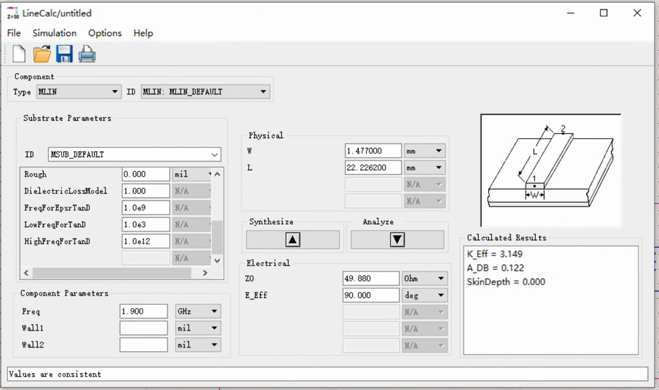

Use the design guide, finally we get all the data we use in branch-line coupler:

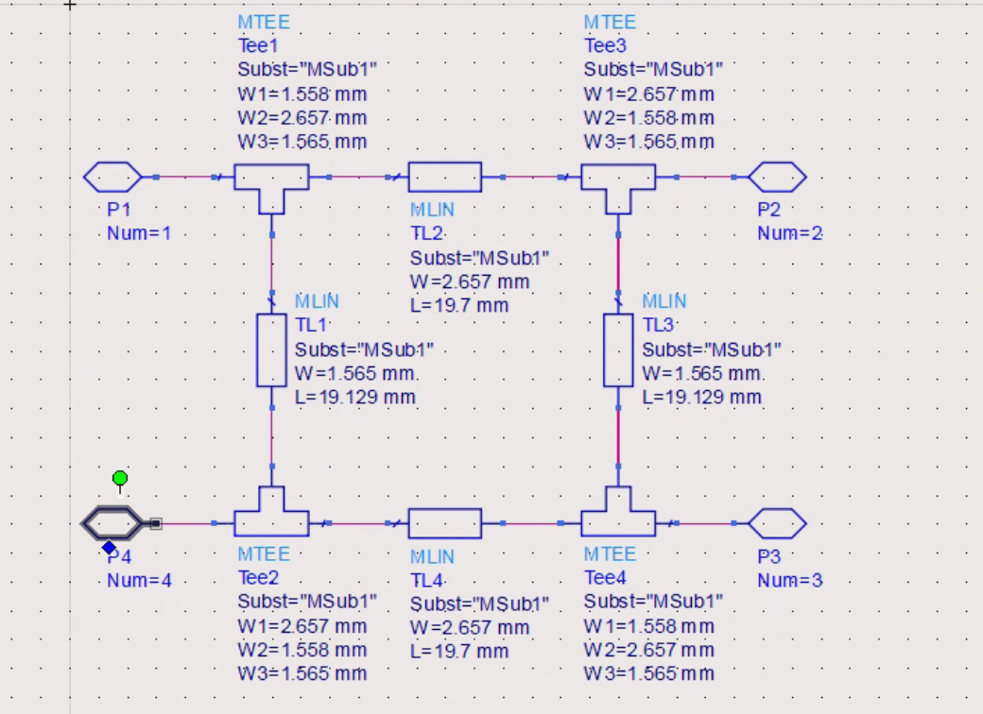

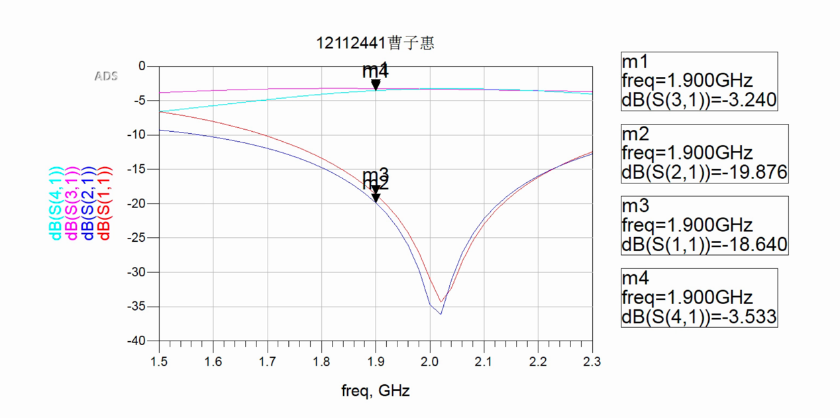

Add 50 ohm microstrip wire to each port：

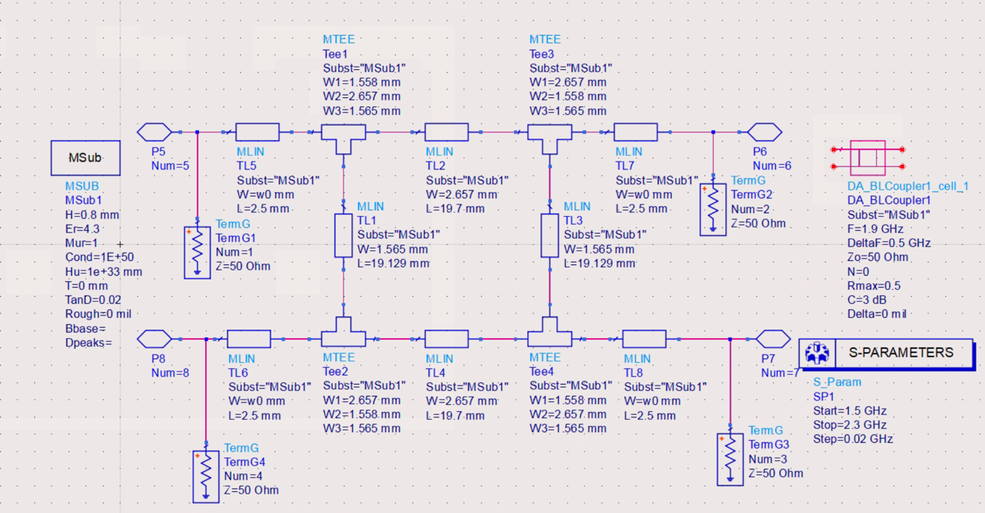

Set the goal，then we get the results after optimization：

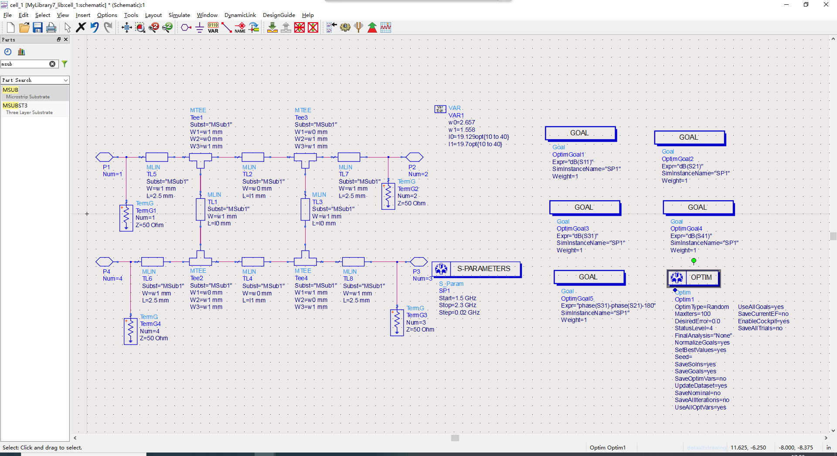

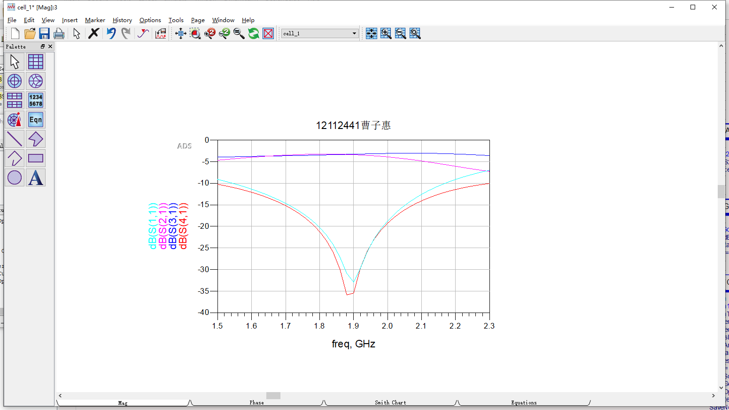

* The simulation results

1. In ADS, layout the PCB diagram directly:

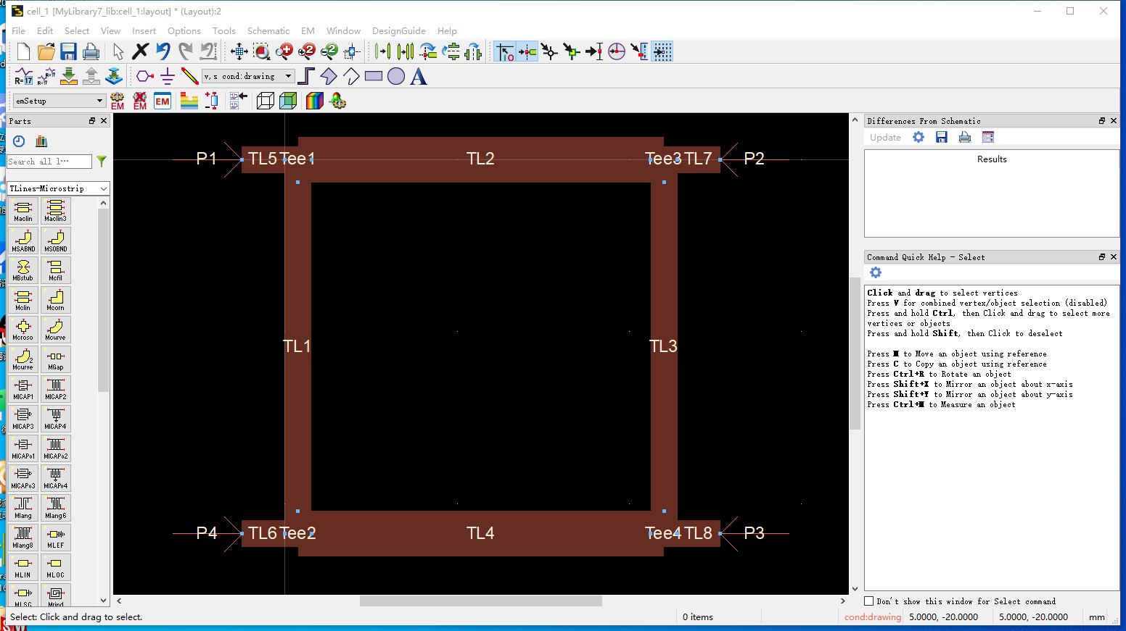

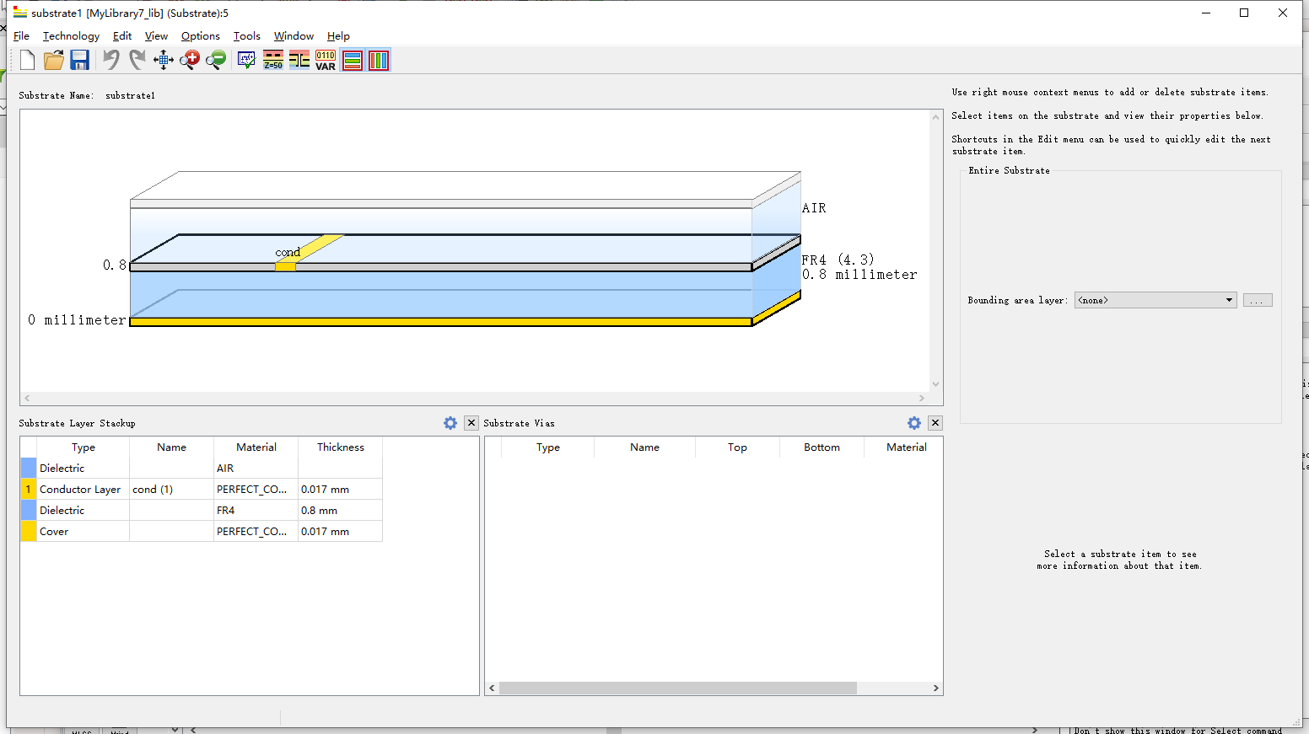

And the simulate results are：

1. input and output return loss

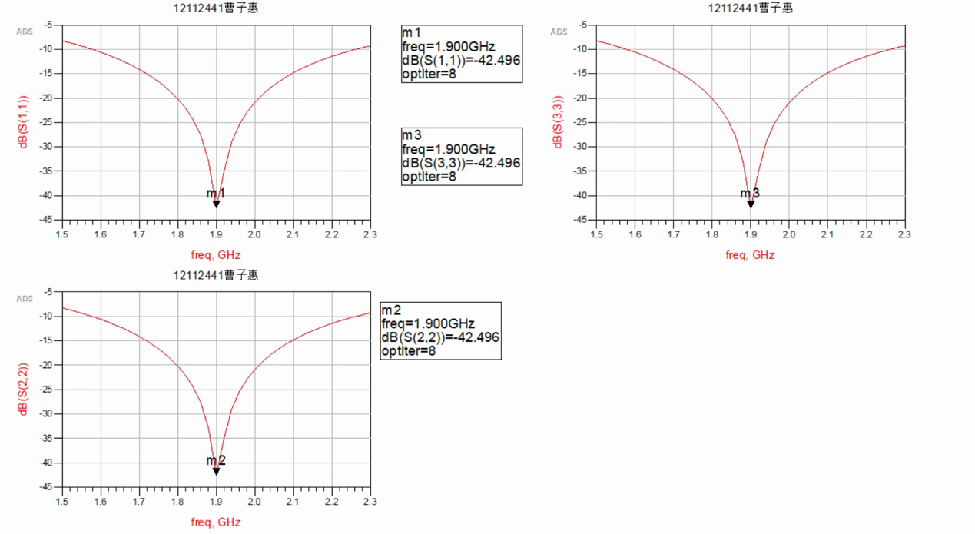

It is clearly that input and output return loss > 22dB

1. Insertion loss

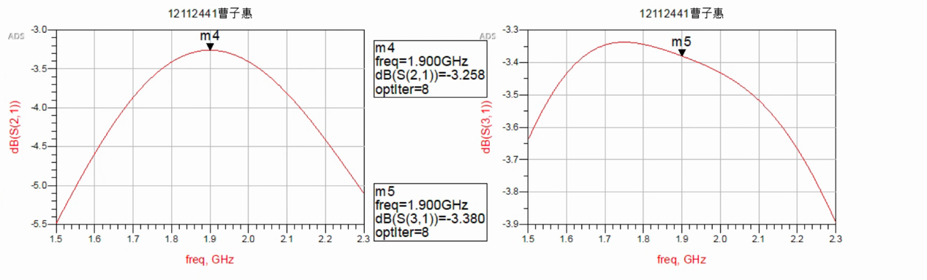

It is clearly that insertion loss < 3.8dB

1. Isolation 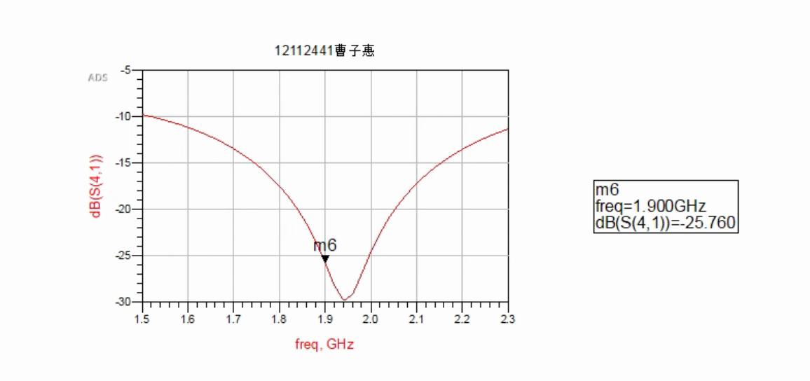

It is clearly that isolation > 25dB

1. Output phase difference

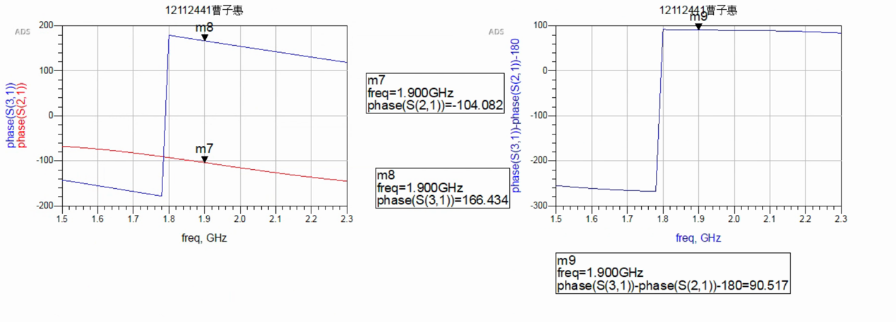

It is clearly that output phase difference = 90°±5°

1. Adopt HFSS to conduct EM simulation

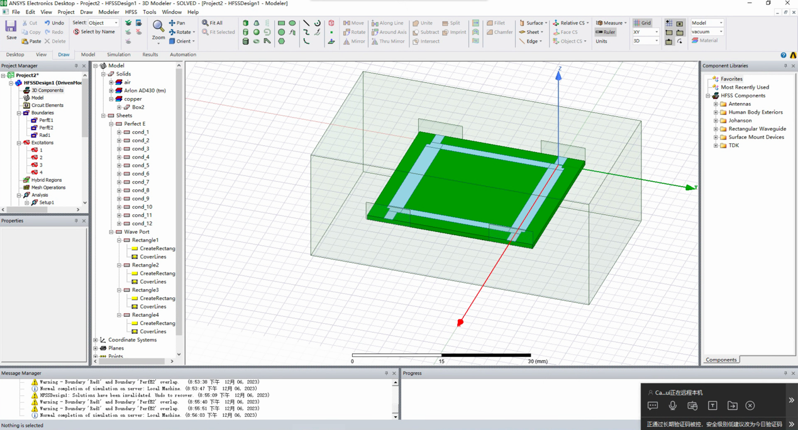

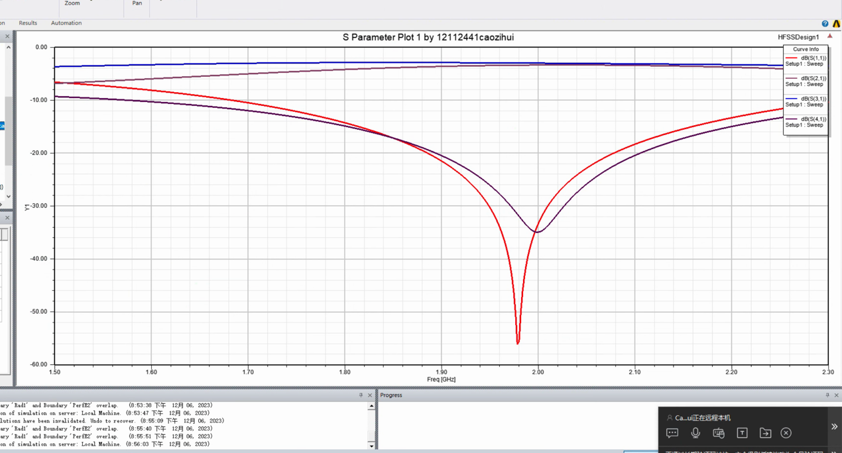

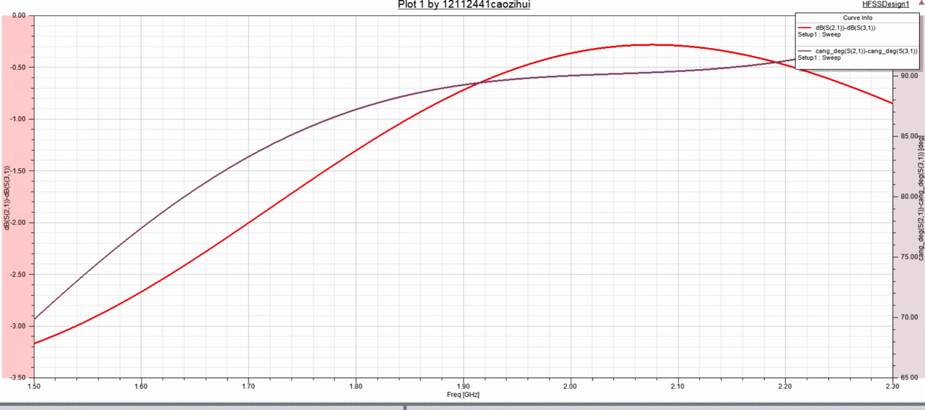

Simulation results are similar to those with ADS.

As the air box is 27.816mm*49.344mm*20mm, the maximum PCB size are less than 90*90mm.

